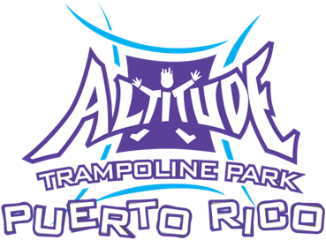
Altitude Trampoline Park Dodge Ball Tournament

TEAM NAME ____________________________________________________________________

TEAM CAPTAIN______________________________________________________
MOBILE PHONE_____________________________
AGE____________________
E-MAIL_____________________________________

TEAM PLAYER______________________________________________________
MOBILE PHONE_____________________________
AGE____________________
E-MAIL_____________________________________

TEAM PLAYER______________________________________________________
MOBILE PHONE_____________________________
AGE____________________
E-MAIL_____________________________________

TEAM PLAYER______________________________________________________
MOBILE PHONE_____________________________
AGE____________________
E-MAIL_____________________________________

TEAM PLAYER______________________________________________________
MOBILE PHONE_____________________________
AGE____________________
E-MAIL_____________________________________

TEAM PLAYER______________________________________________________
MOBILE PHONE_____________________________
AGE____________________
E-MAIL_____________________________________

TEAM PLAYER______________________________________________________
MOBILE PHONE_____________________________
AGE____________________
E-MAIL_____________________________________

TEAM PLAYER______________________________________________________
MOBILE PHONE_____________________________
AGE____________________
E-MAIL_____________________________________

Release/ Agreement: By signing this document, I agree to the following: any time before, during or after the event (including, but not limited to the practices of the tournament or team), images of the participants (including but not limited to the players) can be taken by event officials, including but not limited to, marketing purposes. By registering in this tournament, participants grant the organizers, promoters and agents of the event, unlimited use of the aforementioned images.

I recognize that I am in complete agreement with the parameters, regulations and rules established by the administration of Altitude Trampoline Park (including, but not limited to the park and event officials); likewise I acknowledge that I signed and agreed with the required waiver to participate in the park activities or use of its facilities.

